**PROJECT DESIGN PHASE -1**

**SOLUTION ARCHITECTURE**

|  |  |
| --- | --- |
| **DATE**: | 29/09/2022 |
| **TEAM ID:** | PNT2022TMID41953 |
| **PROJECT NAME:** | Hazardous Area Monitoring for Industrial Plant powered by IOT |
| **MAXIMUM MARKS:** | 4 Marks |

**SOLUTION ARCHITECTURE :**

Solution architecture bridges the gap between business problem and technology solution. It is a complex process with many sub processes.

Its goal are :

* Monitor the real time industrial conditions using various sensors.
* Pass the information using General packet radio service modem and store those information in the cloud which can be viewed by the industrial system.
* This system actively records and analyze the conditions to ensure safety of the workers and the environment around workers.
* When the conditions becomes critical beyond the safety limits, alert message are sent to industrial system and also buzzer sound is activated.
* This provides specifications according to which solution is defined and managed. • Gives the best technology solution to solve the problem.



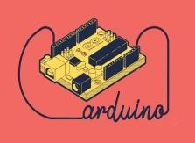

**PIR**

**SENSOR**

**ARDUINO**

**GPRS**

**MODEM**

**CLOUD**

**WEB**

**APPLICATION**

**FIRE**

**SMOKE**

**TEMPERATURE**

**INDUSTRIAL ACTIVITY MONITOR**

**SENSOR**

**SENSOR**

**SENSOR**

**BUZZER**

**ALERT**

**MESSAGE**

**ALERT**

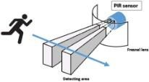

**USER MOBILE**